Given a JSON string in ***Task1_data.sql*** file. The query from this file returns an example of JSON data that might come from data sources to DWH.

**Task**: parse given JSON string to be able to get the following output in table format:

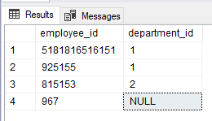

General requirements to query:

1. The query structure should meet to one that is shown on the below picture.

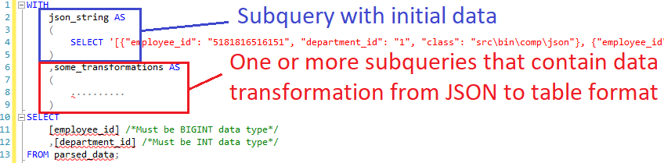

1. Query should **NOT** contain in-built SQL Server features of work with JSON data (expressions like **ISJSON**, **JSON_VALUE**, **JSON_QUERY**, **JSON_MODIFY**, etc.).
2. Query should **NOT** include any commands from procedural extension of SQL. It should be only one single SQL statement.
3. Query must be able to work with any number of elements from JSON message. Currently there are 3 items but there should be a possibility to pass 1, 2, 5, 10 or more elements with the same structure to the query.
4. Query should give an output with following data types: **employee_id** **BIGINT**, **department_id** **INT**.